# **Chapter 5: Application of Computer Science**

**All Lectures Uploaded on YouTube:**

[**https://tinyurl.com/fkm9-cs**](https://tinyurl.com/fkm9-cs)



This unit is dedicated to learning about popular fields in Computer Science which include Artificial Intelligence, Machine Learning and Cloud Computing. It also describes the importance of data and social implications of using it to make decisions and provide services.

**5.1 Artificial Intelligence and Machine Learning**

**5.1.1 Artificial Intelligence**

Artificial Intelligence (AI) is a field of computer science that focuses on developing computer-controlled machines capable of performing tasks that normally require human intelligence. AI-based machines function as if they are equipped with an intelligent brain, allowing them to analyze situations, make decisions, and solve complex problems effectively.

With the help of AI technology, computers can be trained to carry out a wide range of tasks by mimicking human actions and thinking patterns. It involves the creation of intelligent machines as well as the development of smart software systems that can learn, reason, and adapt. In simple terms, AI refers to the intelligence demonstrated by machines to assist humans in solving problems more efficiently and with greater accuracy. Artificial Intelligence is transforming the world by enabling solutions to complex challenges that were previously difficult or impossible to achieve.

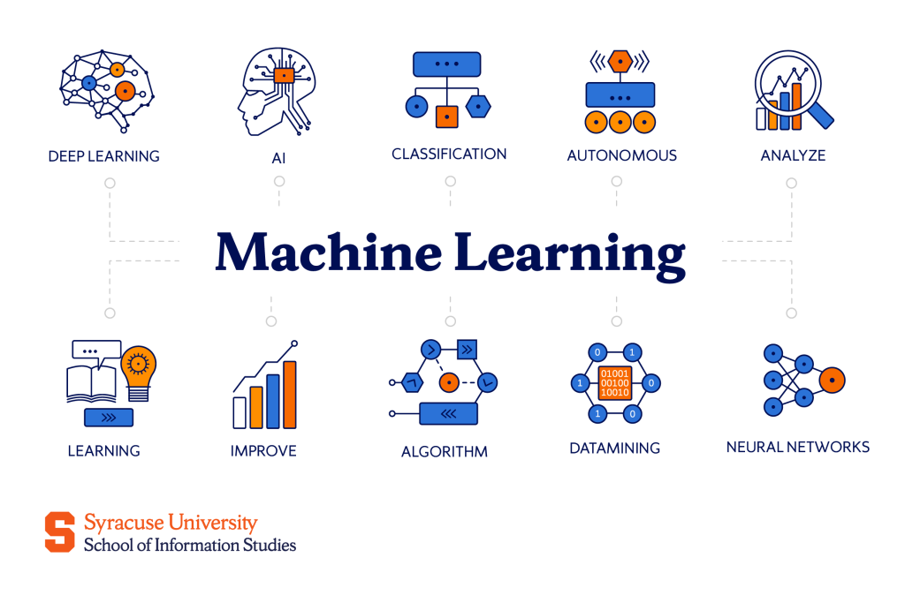

**5.1.2 Machine Learning**

Machine learning is a subfield of Artificial Intelligence that enables computers to learn from data and past experience in a manner similar to human learning, without being explicitly programmed for every task. AI systems rely on machine learning algorithms to analyze data and predict desired outputs. These algorithms allow computers to be trained using data inputs, which are then processed and examined to generate accurate and reliable results. Machine learning focuses on identifying patterns within large datasets to create models that support automated and intelligent decision-making. As more sample data is provided, machine learning algorithms continuously refine and enhance their performance and decision-making ability over time.

Machine learning has emerged as a highly valuable technique for addressing problems across a wide range of fields. Its applications include image and speech recognition, fraud detection in banking transactions, spam filtering and email phishing detection, image and video analysis, language translation, virtual personal assistants, search engines such as Google, self-driving vehicles, manufacturing systems, and medical devices, among others. Figure 5.1 illustrates the various stages involved in the development of an AI algorithm.

**Types of Machine Learning**

There are two types of machine learning, that is, supervised and unsupervised machine learning.

**Supervised Machine Learning**

Supervised Machine Learning is a learning approach in which algorithms are trained using a dataset that contains both known input values and their corresponding correct output results. These algorithms use the labeled data to construct a model that can make accurate predictions. The main objective of supervised learning is to understand the relationship between inputs and outputs so that the system can correctly map inputs to the expected results. After the model is trained, it can be applied to new, unseen data to generate predictions.

Machine learning techniques are especially useful for solving complex problems that involve large volumes of data, particularly in situations where no fixed mathematical formula exists to determine the output.

For example, if the goal is to predict the price of a car, a dataset must be prepared that includes various input features related to cars, such as different characteristics that influence their prices.

· Engine type and power

· Transmission type (manual/automatic)

· Number of seats

· Front-wheel/rear-wheel drive

· Keyless entry

· Push button start

· Safety features

· Country of manufacturing

We have to label the cars with their prices. After entering the data for a large number of cars, we can train the algorithm and create a model. The price of a new car can be predicted based on the input fed in the supervised learning algorithm.

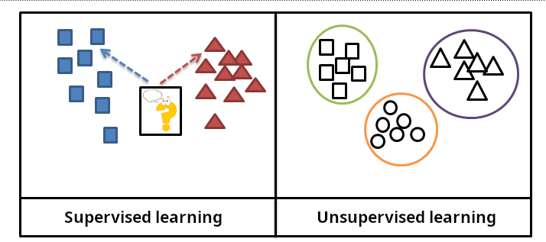

**Unsupervised Machine Learning:**

In unsupervised learning, the training data is not previously labeled and is unfamiliar to the system. Unlabeled data means that the information does not belong to any predefined category or class. This raw data is provided to the machine learning algorithm so that it can learn directly from it. The trained model then attempts to identify structures, relationships, or patterns within the data and produces meaningful results.

Unsupervised learning algorithms focus on discovering hidden patterns present in the input data. They commonly use a learning method called clustering, which involves grouping similar data points together. By detecting underlying patterns or natural groupings, unsupervised learning helps organize data in a way that is useful for clustering, exploration, and further data analysis.

For example, a bank wants to predict how capable an applicant is of repaying the loan. A machine learning system is to be set up to ensure that the loan is given to the applicant who can repay it. In this case, the applicant will provide the data about his monthly income, debt, credit history, etc. along with his personal data such as age, mobile number, gender, etc. Information about age, mobile number and gender are not important for determining the loan risk. Therefore, age, mobile number and gender can be eliminated for setting up the machine learning system for predicting the loan risk.

The machine learning process consists of 5 stages as shown in Fig. 5.1:

· **a) Collection of training data**

· **b) Creating algorithm**

· **c) Learning process**

· **d) Creating training model**

· **e) Predicting results**

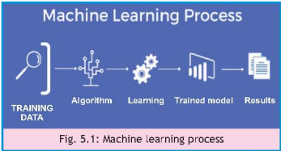

AI machine learning algorithms shown in Fig. 5.2 can make errors and produce wrong results as they do not apply formulas like traditional algorithms. It is difficult to find out.

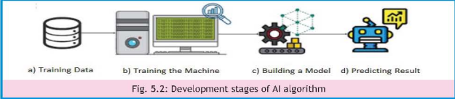

AI machine learning algorithms shown in **Fig. 5.2** can make errors and produce wrong results as they do not apply formulas like traditional algorithms. It is difficult to find out what went wrong in the AI algorithms as there is no proper breakdown on how the AI algorithm is making decisions. Therefore, sometimes AI algorithms can make wrong decisions. AI algorithms with lack of transparency can create dangerous AI systems which can make wrong decisions and harm people or destroy humanity. Behavior of AI algorithms may even be unpredictable to the developers or experts. Inaccuracy in AI algorithms work in the background when AI systems are used. Inaccuracy in algorithms can put people in jail, cause business to collapse or even death of a patient.

The following are some harms or disadvantages of AI algorithms:

* AI algorithms are developed by humans who can intentionally or unintentionally introduce bias in them. These algorithms can produce biased results that can lead to discriminatory consequences on the grounds such as ethnicity, gender or age.
* Driverless self-driving cars can have an accident. This shows how AI algorithms can cause death.
* Errors in AI algorithms in healthcare systems can produce inaccurate information. For example, the AI system can recommend a wrong medicine for a patient which can be very harmful and can even cause death.
* Hackers can develop powerful AI algorithms to bypass cybersecurity and cause malicious cyberattacks.
* AI based automation can lead to job losses in many areas such as automobile manufacturing, business, education, healthcare, agriculture, etc.
* Dependence on AI systems can cause loss of creativity and critical thinking skills in humans.
* Unexpected behavior of AI systems can result in having a negative impact on individuals and society as a whole. AI systems that do not observe human values can lead to big disasters.

**5.1.3 Usage of AI for Benefiting People**

Designers of AI algorithms must instill moral and ethical values in AI systems and focus on benefiting people.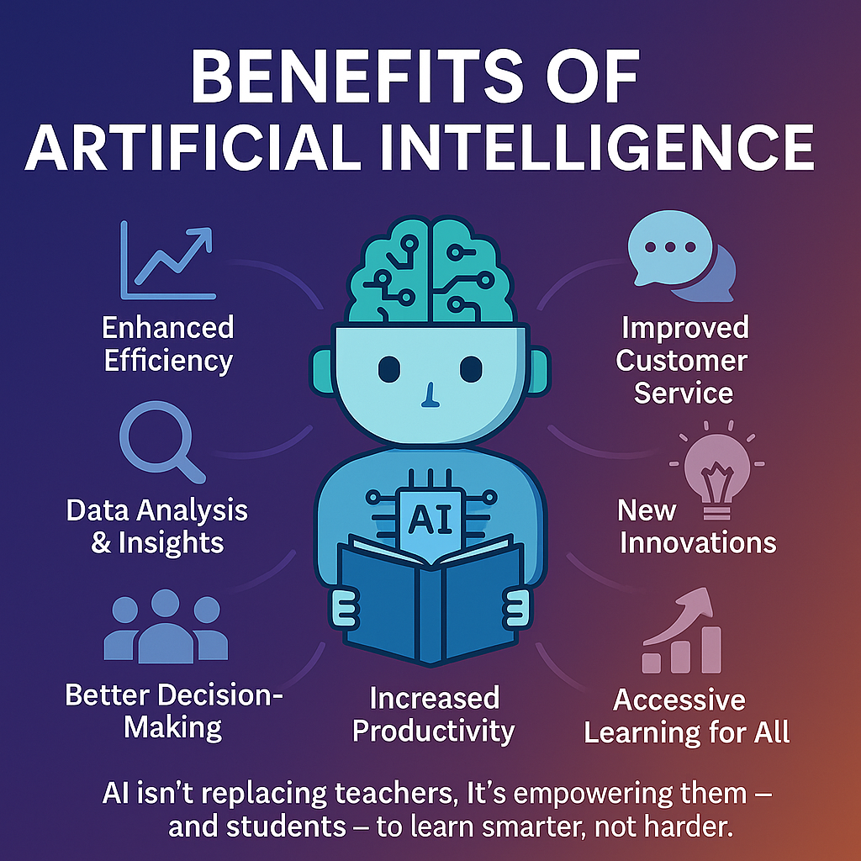

There are many benefits of AI systems. Utilizations of AI based systems are transforming our day-to-day activities and improving our lifestyle. It helps in solving many complex problems that depended on human intelligence in the past.

The following are some important benefits of using AI systems.

* AI-based systems make correct decisions and help us in solving complex problems efficiently and increase productivity.
* AI systems used in hospitals provide better diagnosis and treatment of diseases at an early stage such as cancer.
* Help in design and production of high quality products and increase production in a safe environment.
* Help in travel and transportation by suggesting shortest routes for the drivers and inform about traffic conditions in real time.

**5.1.4 Ethical Issues in Using Popular AI Tools**

AI tool is an intelligent application software used to solve problems. It analyzes vast amounts of training data and makes predictions to solve problems efficiently and improve productivity.

**ChatGPT**ChatGPT stands for *Chat Generative Pre-trained Transformer* and is developed by OpenAI, an American artificial intelligence research laboratory. ChatGPT assists users in completing tasks such as writing essays, drafting emails, and generating computer code. It works as a user-friendly virtual assistant that responds to questions in text form. Although it is a highly beneficial AI tool, it also gives rise to several ethical concerns. These concerns include the spread of misinformation, academic cheating, and plagiarism in schools and universities, which may negatively affect the teaching and learning process as well as student assessment. Additional issues related to ChatGPT involve bias, discrimination, and concerns regarding data privacy and security. Figure 5.3 illustrates the applications of ChatGPT.

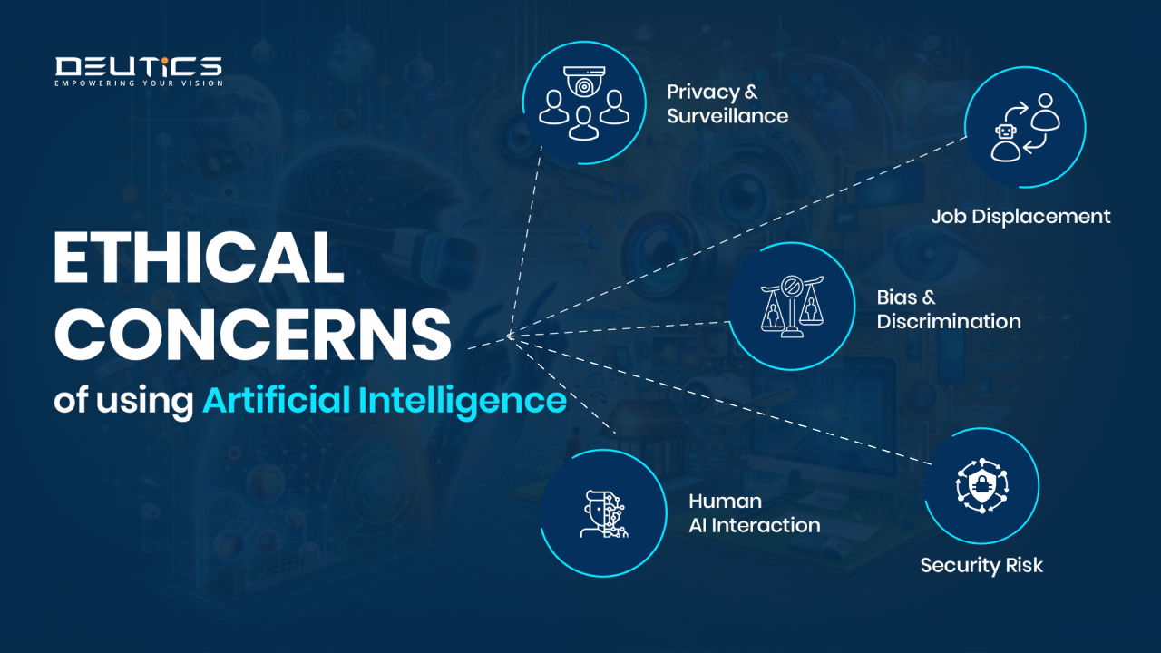

**Grammarly**

Grammarly is an AI-based tool designed to detect and correct spelling and grammatical errors in written documents. It offers a reliable platform for enhancing writing skills. To use Grammarly, users simply copy and paste their text into the system, where it automatically reviews the content and suggests corrections. The tool ensures user data protection by securing documents and preventing unauthorized account access. However, Grammarly is not completely error-free and may sometimes provide inaccurate suggestions or miss certain mistakes. Due to these limitations, it cannot fully replace manual proofreading.

**Lovo AI**Lovo AI is an artificial intelligence–powered tool that converts written text into spoken audio. It is an award-winning platform known for producing highly realistic text-to-speech output. Lovo AI uses advanced AI techniques to select the most appropriate voice for the given text. The tool supports over 500 high-quality voices and more than 100 languages. It is simple to use and is widely applied in creating audio and video content for purposes such as advertising, marketing, education, and training. keep the main points.

There are several ethical concerns that need to be addressed while developing text-to-voice software. Developers must ensure that any personal data collected during processing is handled securely and not misused, so that users’ privacy is fully protected. The data used to train voice-based AI systems should be free from bias to avoid unfair or misleading outcomes. In addition, developers should clearly explain how their AI algorithms function in order to maintain transparency. AI tools that generate new content such as audio, video, music, text, and images may also lead to issues related to copyright violations and the creation of harmful content. Therefore, it is the responsibility of developers to design voice AI systems that are beneficial to society and do not cause harm to individuals.

**Virtual Assistants**A virtual assistant is an interactive AI-based application that is capable of understanding and responding to natural language. Common examples of virtual assistants include Apple’s Siri, Amazon Alexa, Google Assistant, ChatGPT, and Microsoft Cortana. Users can ask questions or give commands, and the virtual assistant provides appropriate responses. Virtual assistants have become an important part of everyday life and are able to perform many tasks such as sending messages, making phone calls, playing music, online shopping, searching the internet, and composing emails. Figure 5.4 shows Google Assistant displayed on a computer screen

Developers of virtual assistants encounter several ethical challenges. Virtual assistants collect and store information about the users who interact with them, and users are often unaware of where this data is stored or how it is safeguarded against privacy and security threats. Therefore, developers of virtual assistants must act in an honest and responsible manner and follow established ethical guidelines. They should ensure that users’ information is properly protected, not misused, and does not cause any form of harm to individuals or society.

**5.2. Different Areas of AI**

AI has become a very useful technology for solving problems related to many areas. These include healthcare, education, transportation, research and development, customer support, biometrics, fake account verification, advertising and marketing, helping wildlife, cybersecurity, agriculture, business, defense, etc. **Fig. 5.5** shows application of AI in various areas.

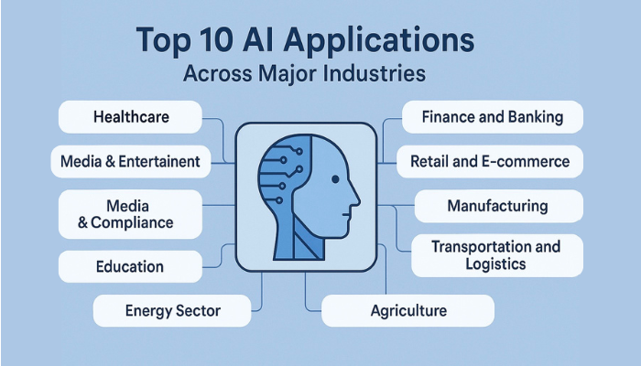

**5.2.1 Speech Recognition**

Speech recognition is used for a variety of purposes. One common use is converting spoken words into written text, which helps save time compared to typing. It is widely used in virtual assistants such as Siri and Alexa. A virtual assistant is a software program that receives voice commands and performs different tasks on devices like mobile phones, tablets, and smartwatches. Speech recognition is also highly beneficial for people with physical disabilities who may find it difficult to use a keyboard.

Despite its advantages, speech recognition has some limitations. Differences in accent and pronunciation among users can make it challenging for the system to accurately understand spoken words. Due to occasional communication errors, some users may feel reluctant to rely on this technology. However, with continuous advancements, the accuracy and efficiency of speech recognition systems are steadily improving.

**5.2.2 Computer Vision**

Computer vision is a branch of artificial intelligence that allows computer systems to extract useful and meaningful information from digital images and videos. This technology works by using cameras, large datasets, and specialized algorithms.

In computer vision, a vast amount of visual data such as images and videos is provided to the system. The computer repeatedly analyzes this data until it can identify, recognize, and differentiate between objects and patterns. Once the system develops a strong understanding of the data, it is able to perform automated tasks. Just as AI enables computers to think, computer vision gives machines the ability to see.

Computer vision is applied in many areas, including healthcare, security and surveillance, facial recognition, self-driving vehicles, parking space detection, traffic flow monitoring, manufacturing, and construction. Figures 5.6 and 5.7 show examples of computer vision applications at road intersections and in traffic flow analysis.

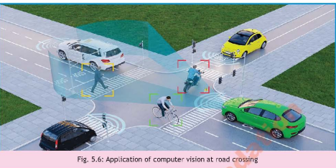

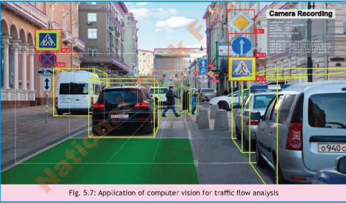

**5.2.3 Natural Language Processing**

Natural Language Processing (NLP) is a branch of Artificial Intelligence that focuses on enabling computers to understand, interpret, and respond to human language in both spoken and written forms, similar to the way humans communicate. The main goal of NLP is to make interaction between humans and computers simple and natural by using everyday language. In simple terms, NLP involves training computers to process human language and perform appropriate actions based on it. This technology also helps in automating many tasks and improving work efficiency.

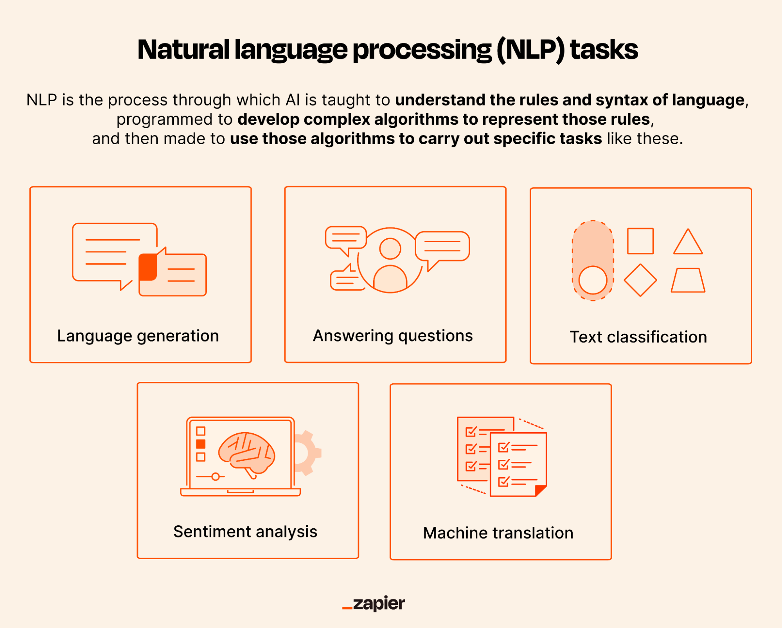

NLP is a challenging area because human language is complex and varied. Therefore, advanced and sophisticated algorithms are required to analyze, understand, and translate natural language instead of relying on traditional computer programming languages.

Some common applications of NLP in daily life include:

* Language translation (such as Google Translate)
* Email filtering and spam detection
* Voice recognition systems
* Web and internet search engines
* Chatbots
* Personal assistants (Siri, Alexa, Google Assistant)
* Spell checking and grammar correction
* Sentiment analysis
* Detection of bias and fake news
* Targeted advertising

**5.2.4 Expert Systems**

An expert system is an interactive AI-based computer program developed to solve complex problems by mimicking the decision-making ability of human experts. It uses stored knowledge and logical reasoning to provide solutions related to a particular domain or field of expertise.

**Applications of Expert Systems**Expert systems are used in many different areas, including:

* Medical diagnosis in hospitals, such as detecting cancer
* Loan evaluation and fraud detection in the finance sector
* Cybersecurity systems
* Product design and manufacturing, for example in the automobile industry
* Project planning and scheduling
* Monitoring and controlling plant operations

**5.2.5 Development of Expert Systems**

The development of an expert system involves several important steps:

· A large amount of specialized knowledge is collected from experienced professionals and experts in a specific field. This knowledge is then stored in the expert system to form a knowledge base.

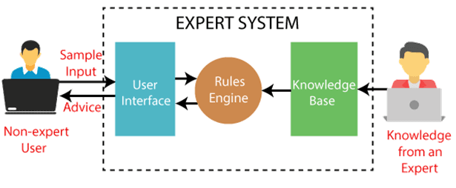

* When a user submits a query, the expert system requests relevant information by asking the user to fill in a questionnaire or provide required details.
* The system then applies predefined rules and reasoning methods to retrieve and analyze information from the knowledge base in order to determine a solution.
* Finally, the expert system presents the solution or recommendation to the end user.

**5.3 Applications of AI:**

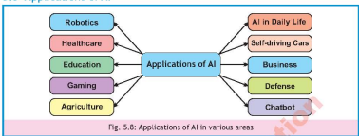

**5.3.1 Robotics**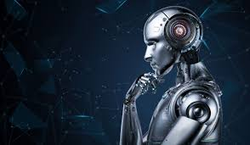

Robotics is the branch of technology that deals with the design and use of computer-controlled machines capable of performing specific tasks with minimal or no human intervention. A robot is a sophisticated machine equipped with sensors, cameras, microphones, control systems, and other components that allow it to perceive its environment and act accordingly.

The design and development of robots involve the integration of multiple disciplines, including mechanical engineering, electrical engineering, structural engineering, mathematics, and physics. Figure 5.9 illustrates the application of robotics in the automotive industry.

* Robots are employed in a wide range of areas, such as:
* Manufacturing and assembly lines in industries
* Transporting goods and materials in warehouses
* Packaging medicines in pharmaceutical operations
* Operating in extreme temperature conditions
* Handling hazardous materials in high-risk or dangerous environments

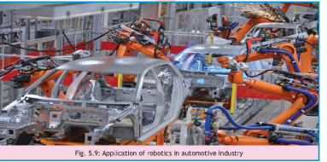

**5.3.2 Healthcare:**

AI-based software is fed in various machines used in hospitals to help in diagnosis of certain diseases such as cancer. AI-based microscopes can scan harmful substances and bacteria in samples of blood. AI-based patient monitoring systems in ICU help in measuring real-time data such as heart-beat, blood pressure, temperature, etc. that helps doctors in analyzing patient's health conditions. AI software provides personalized interaction between the patient and the hospital in managing health by reducing visits to the hospital. Fig. 5.10 shows application of AI in healthcare.

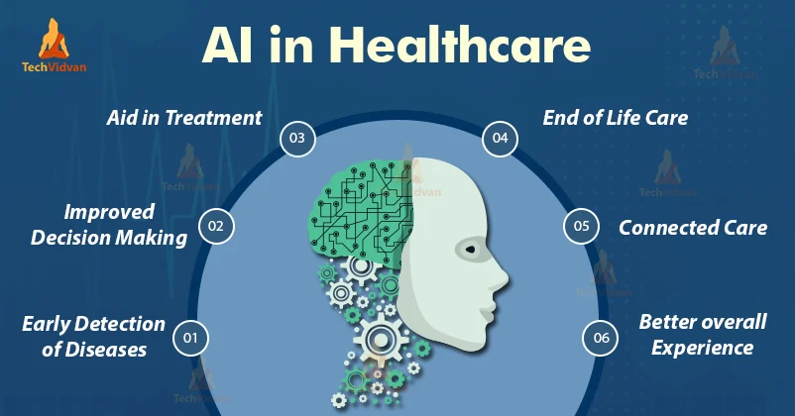

**5.3.3 Education:**

AI-based systems in education have many benefits for students, teachers and school/university administration. It enhances students' learning and helps teachers to carry out their tasks efficiently to provide quality education. AI based systems adapt to meet each student's individual learning needs. It helps teachers in grading students' assignments, examinations and essays. It helps educational administrators to schedule courses, create class timetables and analyze students' data to make better decisions. It can help university administration in reviewing each student's enrollment application for admission. Fig. 5.11 shows various applications of AI in education.

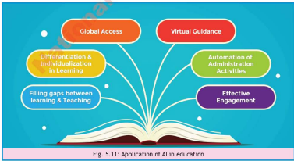

**5.3.4 Gaming:**

AI in gaming refers to the use of computer technology in developing games that give the impression of intelligence and makes the game more challenging, appealing and fun. AI is applied a lot in modern games to make the opponent player seem intelligent to present a challenge to the player. It creates an exciting playing experience to keep the player interested in game.

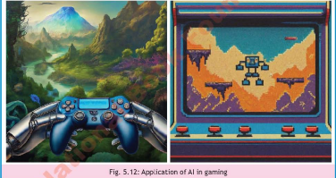

**5.3.5 Agriculture**

AI in agriculture involves the use of advanced AI-based techniques to help farmers grow high-quality crops and increase productivity by using land more efficiently. To address future challenges such as food shortages and livestock management, implementing AI technology and innovative farming methods is essential for maximizing output on existing farmland.

Some key benefits of AI in agriculture include:

* AI can scan images of insects and pests that affect crops and livestock, helping detect problems early and prevent the spread of diseases.
* AI systems, using drones, cameras, and computer vision, monitor livestock health and identify potential issues to reduce the risk of disease transmission.
* AI-powered drones enable precise and efficient spraying of pesticides.
* AI-driven farming machinery, including driverless tractors, smart spraying, and fertilization systems, contributes to higher crop yields.
* AI-based surveillance systems enhance security by preventing unauthorized access from people or animals that could damage crops.

Figure 5.13 shows the application of AI drones in agriculture.

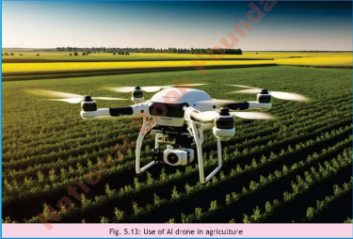

**5.3.6 AI in Our Daily Life**

AI is widely integrated into our everyday lives, often in ways we may not notice. For example:

* Email services use AI to filter spam, sending unwanted messages to the trash or spam folders while showing only relevant emails.
* Mobile phones and laptops utilize AI for facial recognition, providing secure access and identification.
* Search engines like Google and Yahoo employ AI to organize vast amounts of online information, making it easier to access.
* Online shopping platforms use AI to give personalized recommendations based on user behavior.
* The advertisements we see on websites and apps are often powered by AI, which analyzes our browsing and search history to display targeted content.

**5.3.7 Self-Driving Cars**

AI plays a crucial role in the development of self-driving cars. These autonomous vehicles use AI software integrated with devices such as sensors, cameras, and radar systems to navigate roads without a human driver. The AI system continuously collects data from these devices and makes real-time decisions to control the vehicle safely. Several automobile companies, including Audi, BMW, Volkswagen, Tesla, General Motors, and Volvo, are actively developing self-driving cars. Figure 5.14 illustrates the application of AI in autonomous vehicles.

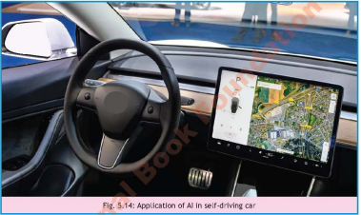

**5.3.8 Business**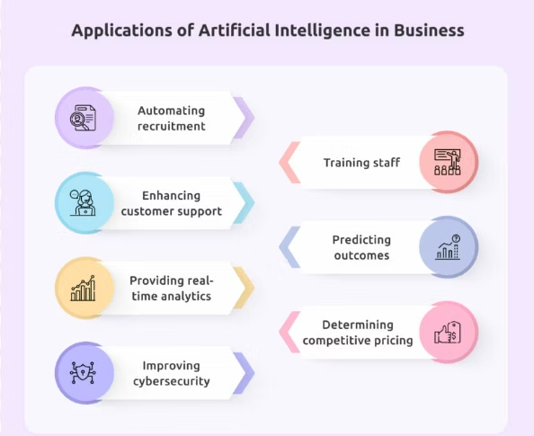

AI is extensively applied in the business sector, particularly in e-commerce, marketing, and business management. AI software helps manage daily operations efficiently and offers numerous advantages, such as enhancing productivity, supporting accurate decision-making, and improving overall efficiency. The use of AI in business allows companies to provide better customer service, support business growth, and increase revenue. Additionally, AI assists in cybersecurity, smart pricing strategies, and automated recruitment processes.

**5.3.9 Defense**

AI is also employed in defense and security systems to detect potential cyber threats and prevent unauthorized access to sensitive information. It identifies suspicious activities in computer networks and strengthens overall system security. In addition, AI enhances surveillance, supports the development of advanced weapons and ammunition, and aids in training soldiers through computer-simulated war environments. Figure 5.16 shows the use of AI in armed military drones.

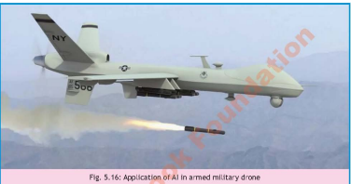

**5.3.10 Chatbot**

A chatbot is a computer program that integrates AI with natural language processing to provide immediate responses to users’ questions via text or voice interactions. Acting as a virtual assistant, it simulates human conversation and automates replies to customer queries. Chatbots offer significant advantages in business, as they are much more cost-effective than employing staff for customer service. They can assist in tasks such as selling products, recruiting employees, and providing support. Moreover, chatbots are available 24/7, ensuring continuous online customer service and helping businesses improve engagement and efficiency.

**5.4 Cloud Computing**

**5.4.1 What is Cloud Computing?**

Cloud computing refers to the delivery of computing services—such as servers, storage, databases, networking, and software—over the Internet by cloud service providers. It allows businesses and organizations to access databases and cloud-based applications remotely from physical servers rather than relying on local, in-house infrastructure. The Internet acts as the “cloud,” enabling users to access and process data from any device connected to the Internet, anywhere in the world. Cloud computing provides an efficient alternative to traditional data processing.

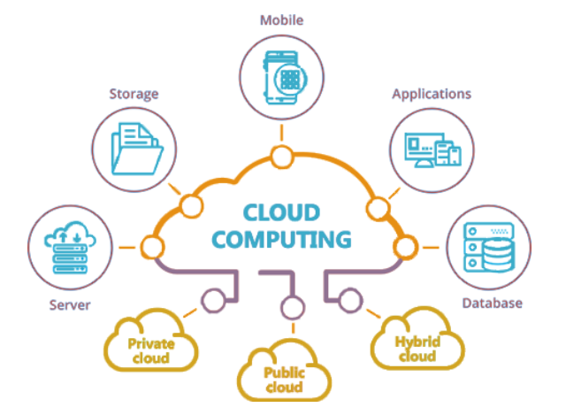

**5.4.2 Types of Cloud Computing**

Cloud computing can be classified into three types: public cloud, private cloud, and hybrid cloud. Figure 5.17 shows examples of AI applications in cloud computing.

**Public Cloud**In the public cloud model, computing resources are owned and managed by a cloud service provider rather than being installed locally within an organization. These resources—such as servers, software, and storage—are delivered to businesses over the Internet. The cloud service provider is responsible for maintaining and managing these resources. Public clouds offer high-speed connectivity, ensuring fast and reliable access to applications and data.

**Private Cloud**In the private cloud model, all computing resources are owned and used exclusively by a single organization. In other words, the cloud infrastructure is dedicated to one organization, and the organization itself is responsible for managing and maintaining the hardware, software, network, and other components. Private clouds provide greater control over servers, data, and network resources, making them suitable for organizations that require enhanced security, privacy, and customization.

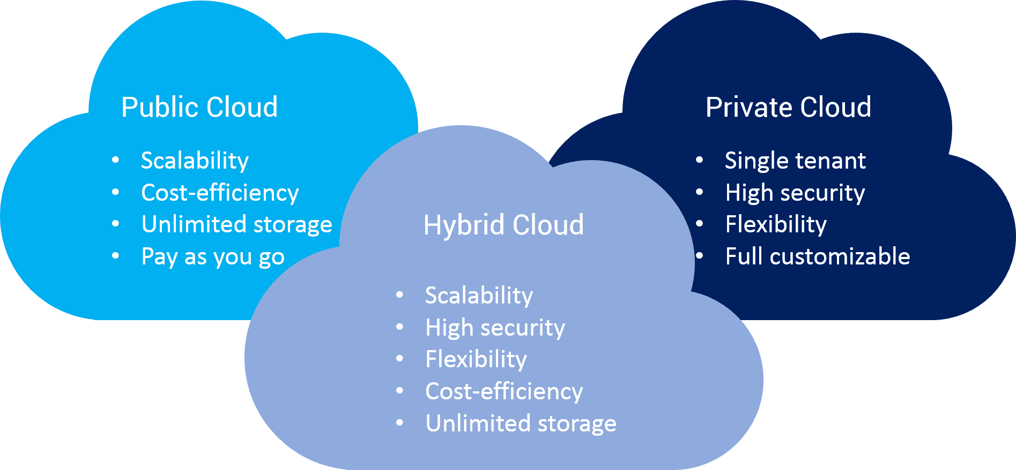

**Hybrid Cloud**A hybrid cloud is a combination of both public and private cloud models. This approach uses technologies that allow data and applications to be shared seamlessly between the public and private cloud environments. Hybrid clouds offer the flexibility of using public cloud resources when needed while maintaining sensitive operations on a private cloud, providing a balance between scalability, cost-efficiency, and control.



